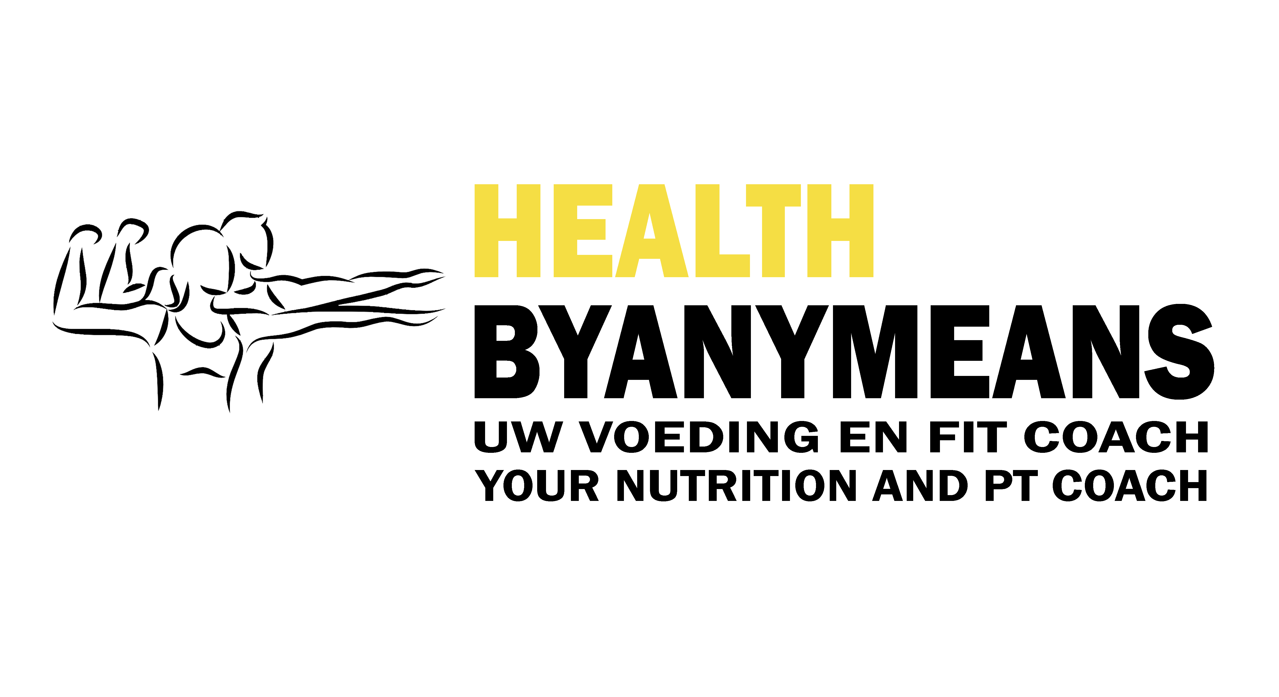
General Conditions of Healthbyanymeans.

- General
  - These general conditions are designation to all offers of Healthbyanymeans. The conditions are valid to everybody and transported to the website of Healthbyanymeans. On request we will send you a written copy.
  - If u order you admit to fully understand and agreeing to the payment and deliver conditions of Healthbyanymeans. Healthbyanymeans maintain the rights to change the conditions of payment and/or deliver after the specific timeframe has ended.
  - Unless a written statement between parties, the general or specific conditions or stipulate of third parties will not be acknowledged by Healthbyanymeans.
  - Healthbyanymeans guarantees that the work method will answer to the agreement and will meet to the specifications of the offer in question.
  - Healthbyanymeans maintain the rights through announcement to change the rates and general conditions.

2. Rates and Fulfillments
2.1 Rates within the timeframe of your purchase will not be raised, unless legal measures are required or before the agreement Healthbyanymeans make price increases through announcement.
2.2 All prices can contain printing or typesetting errors. Through the means of typesetting or printing errors Healthbyanymeans will not be accounting for mistakes.
2.3 Cancelation of an appointment later then 12 hours I will account you for half of the agreed payment.
2.4 For not showing up or being later then 15min after start time I will account you for the full payment.

3. Data management
3.1 If through association with Healthbyanymeans, you agree that your personal information will end up in our database. Healthbyanymeans maintains the law of personal registration and will not be open to third parties.
3.2 Healthbyanymeans respects the privacy of clients and takes care of a trustworthy treatment of your personal data.
3.3 Healthbyanymeans makes use of a mailing list; if you want to be removed from the list make sure you let us know.
3.4 Healthbyanymeans will make use of video footage or pictures for the social media aspect of Healthbyanymeans; we will never do so without permission of the client.

4. Guarantees and Conformity
4.1 The company guarantees that the products and/or services meet the contract specifications stated in the offer, the reasonable requirements of reliability and/or usability and on the date of the conclusion of the agreement existing legal provisions and/or government regulations.
4.2 By the trader, manufacturer or importer as a guarantee scheme does not affect the rights and claims that consumers in respect of a failure to fulfill the obligations of the employer against the employer to claim under the law and/or the distance contract.
4.3 Healthbyanymeans is not liable for damage caused intentionally or equivalent recklessness of non-managerial staff.

5. Deals
5.1 Offers are not binding unless otherwise stated in the offer.
5.2 Upon acceptance of an offer by the buyer, Healthbyanymeans reserves the right to revoke the offer within the period of 7 days after receipt of such acceptance or to deviate.
5.3 Verbal agreements will only hold Healthbyanymeans only after they have been expressly confirmed in writing.
5.4 Healthbyanymeans cannot be held to its offer if the customer should have understood that the offer or any part thereof, is an obvious mistake or error.
5.5 Additions, modifications and/or further agreements are effective only if in writing.
5.6 The customer will receive a free training session after he/she has recruited a new customer and the customer has made the payment.

6. Agreement
6.1 An agreement between Healthbyanymeans and a customer comes into being after an order by Healthbyanymeans feasibility is assessed.
6.2 Healthbyanymeans reserves the right, without giving reasons appointments or training sessions do not accept or accept only on condition that the payment is complete.

7. Images and specifications
7.1 All images; photographs, drawings, etc.; e.g. data concerning weight, dimensions, colors, graphics, labels, etc. on the Healthbyanymeans website only approximate, are indicative and may not lead to damages or rescission of the contract.

8. Ascendency
8.1 Healthbyanymeans is not liable if and when she cannot be fulfilled due to force of ascendency.
8.2 Force ascendency means any strange reason, and any circumstance, which she cannot be at the risk of reasonableness. Delay or failure by our suppliers, disruptions in the Internet, disruptions in the electricity failures in e-mail traffic and disturbances or changes in any third party technology, transport problems, strikes, government measures, supply delay, negligence by suppliers and / or manufacturers of Healthbyanymeans as well as from individuals, disease, defects in appliance or shipment are explicit ascendency.
8.3 Healthbyanymeans reserves in case of force ascendency to suspend the right for its obligations and is also entitled to terminate the contract in whole or in part, or to demand that the contents of the Agreement is amended as detailed as possible. In no event Healthbyanymeans obliged to pay any penalty or damages.
8.4 If Healthbyanymeans at the time the force ascendency already partially fulfilled its obligations or only partially fulfill its obligations it is she entitled to invoice the already delivered or deliverable part separately and the customer is obliged to pay this invoice as if it were a separate contract. This does not apply if the already delivered or deliverable part has no independent value.

9. Liability
9.1 Healthbyanymeans is not liable for damage to the body, or other property caused by improper use of the products or services. Listen to the instructions of the coach, read the instructions for use on the packaging and / or consult you doctor.

10. Retention
10.1 Ownership of all Healthbyanymeans services to the customer sold and delivered goods remains with Healthbyanymeans.
10.2 The goods supplied by Healthbyanymeans, which are subject to retention of title, may not be resold in the context of normal business activities or give away and must never be used as payment.
10.3 The customer is not entitled to pledge under the reservation of ownership to encumber or otherwise.
10.4 The customer gives unconditional and irrevocable consent to Healthbyanymeans or a third party appointed by Healthbyanymeans, in all cases where Healthbyanymeans its property to exercise, all those places where its property is then located and doing business there to take.
10.5 If third parties seize the property delivered or rights to establish or exercise, the customer is obliged Healthbyanymeans as soon as reasonably may be expected to inform.

11. Applicable law and competent court
11.1 All agreements are subject to Dutch law.
11.2 Disputes arising from an agreement between Healthbyanymeans and copper, which can not be resolved by mutual agreement, the competent court within the district of knowledge unless Healthbyanymeans prefer to give the difference to the competent court of the domicile of the buyer subjects, and with the exception of those disputes that fall under the jurisdiction of a magistrate.

